Geometry: Unit 1, Lesson 12

- What tools can be used to create an angle bisector?

Compass, Ruler/Straightedge, Patty Paper

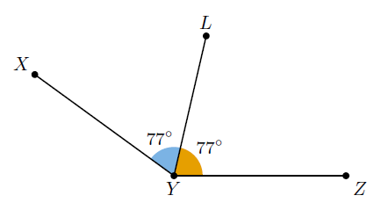
- Is the image shown an angle bisector?

Yes

- What cannot be used to create an angle bisector?

A point

